Dear parents/carers,
I am writing to you with some details about the changes we need to make in September, as a result of COVID 19.
The plans in place are as a result of the DfE guidance, the size of our school community and size of our site. Sadly, the DfE guidance is clear that schools should prevent children and families gathering. Each school has to consider its own individual school setting, the school site, the layout of the building, its staff organisation etc, in order to make plans for each individual school. Solutions and decisions will vary school by school. Neighbouring schools will make different decisions.
Access to the buildings:
Unfortunately, no parents will be allowed into our school buildings. Children will need to be left with staff at the doors. This includes the main school office which will be used as an entrance and exit for Year 6 children. It will therefore not be possible to ‘quickly’ drop things into the school entrance. This is non negotiable. If your child forgets any of their belongings, you will not be able to bring them into school at drop off or during the day.
The only exception to this will be to hand in medication for your child which will still need to be done in person by a parent/carer. If you know your child will need medication in September, please bring this to the school office on the INSET day (Wednesday 2nd September) between 9.30am and 3pm. Thereafter, you should call to make an appointment before bringing medication into the school office.
If you need to speak to a member of staff, please call the main school office on 0191 8141601. If the matter cannot be dealt with over the phone, the office will make a telephone appointment for you with an appropriate member of staff at a mutually convenient time. You are also able to email your child’s class teacher directly. Email addresses are available on the transition pages of the school website.
Access to the site:
We know that families are used to socialising in the school yard and we are sad that this is not going to be possible. But the DfE guidance is clear that we must actively discourage this. The site will be opened promptly at 8:50 am and you will be asked to bring your child through the stated gates where they will enter school through their designated entrance and exit. You are then asked to quickly leave the school site. I remind you that where possible only one adult should attend the site with your children. School gates will be closed at 9:30am. If you arrive at school late you will need to call the school office on 01918141601 to arrange for a member of staff to allow your child access.
Entrance gates and doorways:
We have looked carefully at which entrance gates and doorways children across school will use each day. For some year groups these are changing and may not be the doorway you expected. This is to match our in school bubble arrangements and to spread out year groups as they arrive and leave. Changing doorways for some year groups means that children of different bubbles can be kept apart. Please see the summary information below to see which yard and doorways your child has to
use. There will also be a great deal of signage put around the school site before children return to school to help guide you to the correct entrance and waiting areas.
If your child rides a bike or scooter to school, they must use the existing bike sheds that are allocated for their key stage.
Arriving and departing from school:
Our school, like many others will have staggered start and finish times for every bubble. This system will have to be robustly monitored over the first few weeks. It is dependent on families working together to be sensible and mindful of other families in the school grounds.
The start of the school day:
Start times are either 9am or 9:15am. Please see the summary information below for your child’s drop off time. Staff will be stationed at the doorway your child enters and their teacher will be waiting in the classroom ready for them to arrive and start their learning. All parents should leave the area immediately after drop off.
Nursery start time is 8:45 am and 12:30pm
The end of the school day:
Gates will be opened at 2:55 pm. End times are either 3pm or 3:15pm. Please see the summary information below for your child’s finish time. Parents will need to arrive promptly at their designated time and wait in the designated area. Staff will no longer be responsible for your child once they have left staff at the doorway. Gates will be closed at 3:30pm. If you are late to collect your child you must ring the school office on 0191 8141601 to arrange for your child to be brought to the school main gate for collection.
Nursery pick up time is 11:45 am and 3:30 pm
Siblings
If you have more than one child in school, please drop off the child with the earliest start time first and collect the child who finishes first before the others. If you have siblings who start/finish at the same time, please drop off or collect your youngest child first. Older siblings will be able to walk across the yard to their entrance where they will be met by staff.
Should families not actively socially distance and arrive and leave the site promptly, then we will have to review the start and finish arrangement. This could lead to having to further stagger start and finish times across school.
Thank you in advance for your support and your understanding with this as we know this is very different for us all. If we can work together, we will be able to achieve the safest and swiftest possible start and end to the school day.

Summary of arrangements for each year bubble:

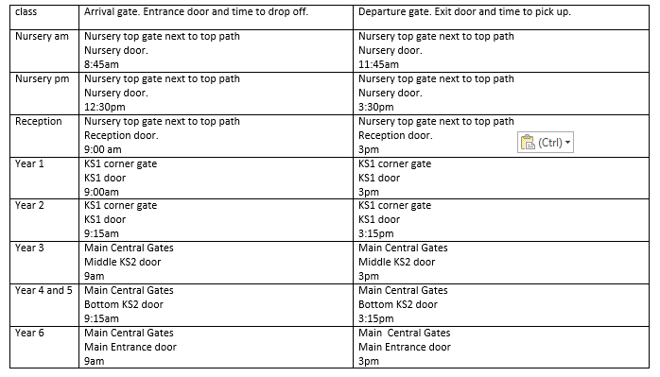
Please remember that if you or your child are displaying any symptoms of Coronavirus then you must not enter the school site.
We very much look forward to seeing your children back in school next week.
Kind Regards
Becky Hawkins
Acting Head Teacher

