In math we will cover place value and will then move onto the four operations (addition, subtractions, multiplications and division). In year 4, children focus on 4 digit numbers and will represent these in different ways (practical, visual, and numerical). Using this knowledge, children will apply these skills to problem solve and reason. This year, your child will be sitting the compulsory year 4 multiplication table check. To further support your child we recommend regular times table practice at home. Let us know if your child needs their Times Table Rockstar log in. |  | Year 4  Autumn Term 2022 |  | In English we will explore change stories (Wanted by Kate Thompson), conquering the monster stories (The Legend of Podkin One Ear by Kieran Larwood) and non fiction texts including discussion texts and instructions. Within these genres children will consolidate their knowledge of capital letters and punctuation whilst incorporating complex sentences into their writing through the use of fronted adverbials and connectives. Children will further use non fiction writing features including bullet points, subheadings and labeled diagrams to orientate and inform the reader. At the end of the term, children will explore winter poetry and relevant poetic features..
The Romans

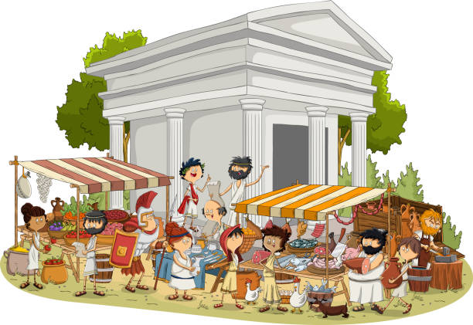
As thinkers in PSHE we will be exploring relationships. This unit includes discussing features of positive relationships with family and friends, how to build safe relationships and exploring the importance of respecting ourselves and others. |  |  |  | As thinkers in RE, we will be exploring Christianity and Jesus. We will look at the term sacred and learn how the bible is sacred to Christians and explore Jesus’ role in the Christian church.
As scientists we will cover two units this term:  In our sound unit, we will learn that sounds travel as vibrations and how sound waves can be represented. We will also learn how sound travels through solids, liquids and gases and how sound is changed from vibrations to what we hear. In our states of matter unit, we will learn about the differences between solids, liquids and gases and recognise that the same material can exist as a solid, a liquid or a gas. We will also learn how to separate solids from liquids. We will investigate the different properties of materials. |  | As geographers and historians, we will explore the Romans. During this theme we will look at the history and culture of the Roman Empire. The children will find out about where the Romans came from and why they invaded different countries. We will be exploring various sources and identifying the validity of each. Children will also take part in a variety of art and design activities and will have the opportunity to participate in a trip to Segedunum. |  | As computer scientists, we will be developing our digital literacy to stay safe online. This will include exploring our responsibility as digital citizens and appropriate behavior online. We will implement these skills for our ‘searching the web’ unit. During this unit we will refine searches and evaluate websites. This will equip us with appropriate skills for our information technology and computer science units.
As sportspeople, we will participate in dance and gymnastics. In dance, children will be learning country dance in which they will develop simple steps while moving to a specific beat. Children will then move onto learning basic gymnastic sequences with a focus on balance. In outdoor PE, We will learn simple invasion tactics and start to think about how to organise ourselves to defend our goals, playing small, uneven-sided games, moving on to even-sided games. |  | As artists and technologists we will be replicating the techniques used by famous and local artists, including Kadinsky, Banksy and Norman Cornish. Children will design and create a range of textile products, using skills in sewing. We will also select appropriate ingredients to make a savory dish. |  | As musicians we will investigate how to compose and improvise music. Children will explore a variety of musical pieces and identify the mood, rhythm and pitch of each.
As linguists, we will be recognising, re-reading and writing numbers to 40 and exploring pets and zoo animals in French. We will be exploring our knowledge of French, verbally and written. The children will also explore geographical features of France. |  | Career links to our learning this term…  - Archeology  - Curation  - Travel  - Author/ Illustration  - Performing Arts |  | Wider curriculum opportunities this term include…  - A trip to Segedunum  - A ‘how to stay safe online’ assembly and workshop  - Lindisfarne Gospels assembly  - Drama club
Texts you can read to support your understanding…  - Wanted by Kate Thompson  - The Legend of Podkin One Ear by Kieran Larwood  - The Rotten Romans by Terry Deary  - A Roman Adventure by Frances Durkin and Grace Cooke.  - So You Think You’ve Got it Bad? A Kids Life in Ancient Rome by Chae Strathie & Marisa Morea. |  | Websites to support learning at home…  - Times Table Rockstars https://ttrockstars.com/  - BBC Bitesize https://www.bbc.co.uk/bitesize  - Oxford Owl https://www.oxfordowl.co.uk/  - Purple Mash https://www.purplemash.com/wallsend  - Topmarks https://www.topmarks.co.uk/ |  | Suggested places for family visits…  - Segedunum  - Great North Children’s Museum  - Vindolanda  - Arbeia Roman Fort  - Centre for Life  - The Baltic Gallery  - Seven Stories

