Dear Parent / Guardian,

Our school provides staff and student email accounts as a teaching and learning tool via North Tyneside LaunchPad (www.ntlp.org.uk), run by North Tyneside Council. This system provides email and other web-based learning tools so students are able to learn effective and responsible use in a safe, monitored environment. Your child’s email account will allow them to communicate with other students, to collaborate on projects and will allow a line of communication between students and teachers that otherwise would not be available.

The system is heavily monitored and filtered, however, technology is ever-evolving and no filtering can ever be 100% guaranteed. As a result, it is important that if a student ever receives an inappropriate email, he/she should retain the email and report it as soon as possible. Consistent with school policy, student email accounts are also subject to monitoring by teachers and other staff within the local authority to ensure appropriate use.

We expect students to demonstrate excellent behaviour and web etiquette while using their school email account and treat it as a tool for learning.

Students will be taught at school about proper email etiquette as well as online and email safety, including the importance of keeping usernames and passwords private. If you have any questions or concerns about your child’s school email account, please don’t hesitate to contact their class teacher.

Step 1 – NTLP Website

https://ntlp.airhead.io/app/noticeboard
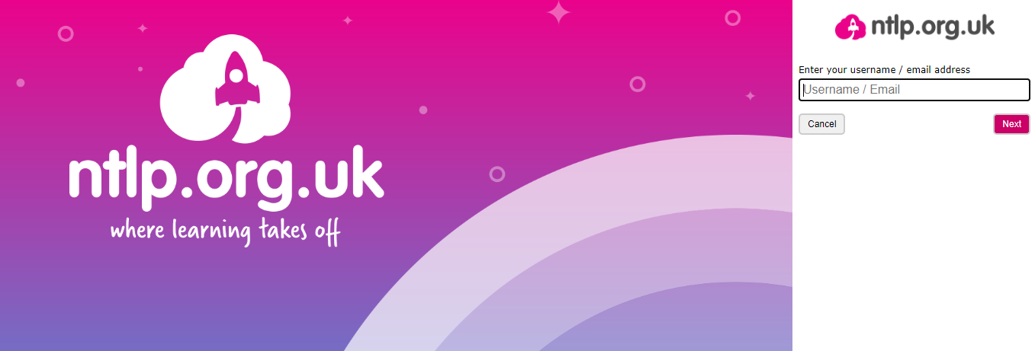

Step 2 – Log in using username and password
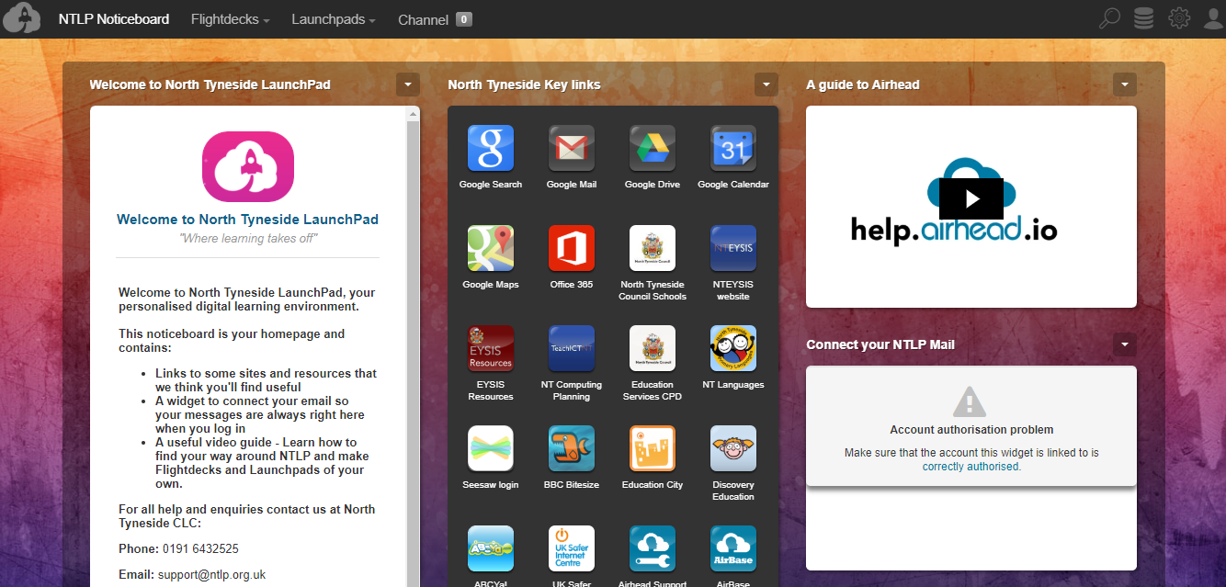
Step 3 – Select Google Mail in key links tab
