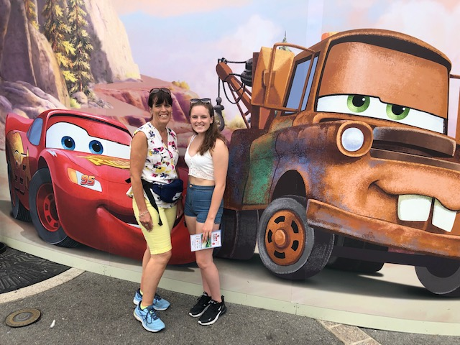*MEET THE TEACHER*

I can’t wait to see you in September but if you have any questions before then please ask your grown up to email me on sharon.fenton@ntlp.org.uk

My Favourites:

Colour: blue

Fruit: strawberries

Book: Charlie and the chocolate factory

Film: Shrek

Season: Summer

Animal: monkey

Hobby: shopping!

Photo placed in here

My name is Mrs Fenton

Our class will be called 2SF

I have been teaching for a long time!!! 28 years.

I am a mum to Millie who is 15 years old.

I have a goldfish called George.

When I’m not at school I like to spend my time being with my family, keeping fit by running and going for bike rides to the coast.

I am so looking forward to getting to know you.

Welcome to year 2