25.3.2020
COVID-19 Review of Arrangements based on Day 2
Dear Parents/Carers
Day 2/3
The second and third day at re-purposed Wallsend Jubilee School have gone smoothly.
Following the introduction of even more stringent measures, take up was even lower today and yesterday and this is vitally important in order to protect the health of children, their key worker parents and the front-line education staff at Wallsend Jubilee.
Some schools are sharing this flow chart which may help parents to establish if they should send their child. If you have used the facility over the last two days or picked up a free school meal you will have seen this attached to our main school gates.

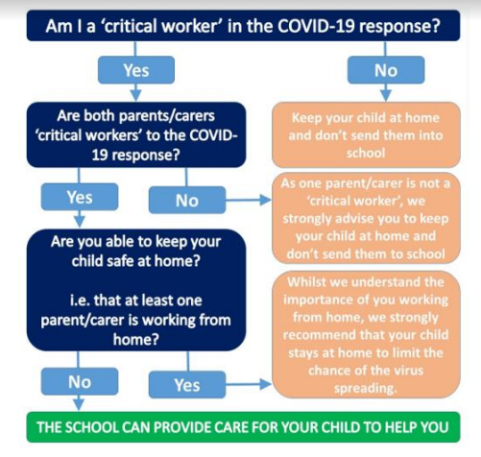

We respectfully ask that when a critical worker is working from home or where there is another parent or responsible carer in the home that children should stay at home. We know that, as a result of more stringent measures, more parents are working at home so we anticipate that take-up will continue to drop over the next few days.
Our current arrangements for drop off and pick up will remain the same for the remainder of the week
Pupils eligible for Free School Meals or Universal School Meals not at school
A reminder that, in the short term, until Easter, for pupils eligible for Free School Meals or Universal School Meals (all pupils in Reception, Y1 or Y2) but not at school, North Tyneside School Meal Service will be providing free school meals in the form of a packed lunch. We will be leaving these in the main entrance of the school and parents/carers of pupils not at school are invited to collect these. Due to social distancing measures, we fully recognise that most parents are not wanting to come and collect these and we have already advised North Tyneside to reduce the number of packed lunches they make. I will be making enquiries regarding a voucher scheme in the coming days.
Easter Holiday Provision
We are now in a position to look at the guidelines which currently state that “we (the government) are asking schools, wherever possible, to maintain provision for children of workers critical to the COVID-19 response over the Easter holidays.” At this stage, we are seeking to scope the level demand. Please note that it might not be possible for Wallsend Jubilee School to maintain provision and we may have to signpost parents to provision elsewhere. We know that officials in the Local Authority are working on establishing a provision. The key principles set out above and in the flow chart would apply “If your work is critical to the COVID-19 response, or you work in one of the critical sectors listed in the guidance, and you cannot keep your child safe at home then your children will be prioritised for education provision.” We would sincerely hope that all alternative avenues could be explored before requesting provision during the Easter holidays. Please complete the form below indicating in as much detail what your requirements would be and we will communicate further on Easter holiday provision in due course.
The school is continually adapting and adjusting to its temporary, new purpose. Please be aware that we really miss the children that are not in school at present and very much look forward to the day when we can welcome everybody back. We would be happy to respond to any queries from any of our parents/carers. Can I remind you that we have two temporary mobile phone numbers available for you to call. Whilst we continue to provide care to the children in school we will make time to look for additional ways to engage with you all. Please sustain the care and consideration you show for one another at this time
Yours sincerely
Mr D Harrison
Head Teacher

Wallsend Jubilee Primary School Easter Holiday
Expression of Interest
These are the key principles:
• If it is at all possible for children to be at home, then they should be.
• If your work is critical to the COVID-19 response, or you work in one of the critical sectors listed in the guidance, and you cannot keep your child safe at home then your children will be prioritised for education provision

Please note that it might not be possible for Wallsend Jubilee Primary School to offer provision but in this event we could signpost parents to provision elsewhere. We would sincerely hope that all alternative avenues could be explored before requesting provision during the Easter holidays. Please complete the form below indicating in as much detail what your requirements would be and we will communicate further on Easter holiday provision in due course
Name of Child |  | Year/Class
Date of Birth
Name of Key Worker
Key Worker Job (please take this from the critical sector in the guidance)

Please Let us know days and times you would need your child to access the provision
Monday 6th April | Tuesday 7th April | Wednesday 8th April | Thursday 9th April | Friday 10th April  Good Friday  TBC
Monday 13th April  Easter Monday  TBC | Tuesday 14th April | Wednesday 15th April | Thursday 16th April | Friday 7th April

