22 October 2020

Dear Parents

With the high rates of COVID-19 in North Tyneside currently, we are asking parents to let the school know if their child tests positive for COVID-19 during the half term break.

If your son or daughter receives a positive COVID-19 test after Friday 23rd October 2020 please email the school immediately on becky.hawkins@wallsendjubileeps.org.uk, David.harrison@wasllsendjubileeps.oirg.uk and provide the following information:

Name of child

Class/year group

Date of the COVID-19 test

Does the child have symptoms? Yes or No

What date did the symptoms start?

What date did the child last attend school?

Or text the above information to the out of hours school COVID contact on 07413041265 or 07426557703 .Please be mindful that these contact numbers are for confirmed COVID results only.

It is very important that you provide this information so that the school can identify any close contacts that your son or daughter may have had in school during their infectious period. The school will then follow up close contacts and request that they isolate for 14 days to prevent further transmission of COVID-19.

Please note that you should also report any close contacts that your child has had outside the school setting through NHS Test and Trace.

Thank you for your help in this matter

Yours sincerely
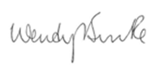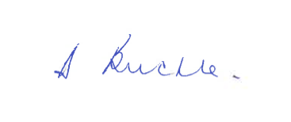
Wendy Burke Diane Buckle
Director of Public Health Assistant Director of Education

