In math we will…develop our skills in number, place value and the four operations (addition, subtraction, multiplication and division). We will continue to practise these in our ‘Maths Meetings’ to consolidate number facts to memory. Moving forward, we will build upon our knowledge of fractions, applying our reasoning to develop skills in mastery. Please encourage your child to practise times tables regularly. |  | Year 5  Autumn Term 2022 |  | In English we will…continue to build upon our spelling, punctuation and grammar skills. We will also be exploring performance poetry, innovating our own defeating the monster stories-after reading ‘Who let the Gods out?’ Then we will be creating Newspaper reports and instructions linked to our learning in History. Finally, we will explore the poem ‘The Highwayman’ to dive deeper into the use of figurative language to engage the reader.
Ancient Greeks
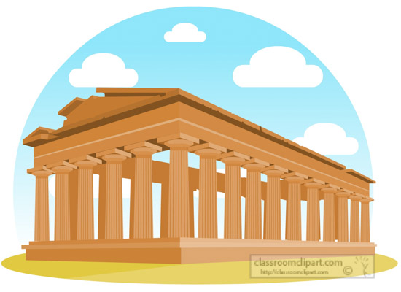
As thinkers in PSHE we will…be exploring what makes a healthy friendship and how to manage peer influence. We will also look at safe relationships as well as respecting ourselves and others. |  |  |  | As thinkers in RE we will…be exploring Christianity, including the true meaning of Christmas.
As scientists we will…explore space and our solar system and the planets within it. We will be learning about the phases of the moon and how the seasons happen. We will also be learning about forces, including gravity and friction. |  | As geographers/historians we will…be looking at the ‘Ancient Greeks’ and how key events have shaped civilisations and understanding how the past can be represented. We will look at a range of sources and know the difference between a primary and a secondary source. |  | As computer scientists we will…be looking at digital literacy and how to stay safe online, including expected behaviour, recognising what is acceptable online, a range of ways to report unacceptable content and who to talk to in addition to building an awareness of digital footprints.
As sportspeople we will…improve our skills in striking and hitting,increasing precision and accuracy in tennis through teamwork and cooperation. In Dance,we will be learning how to perform with expression, whilst telling a story. |  | As artists and technologists we will…continue to develop our sketching skills, create a clay sculpture and look at the sculptures of other artists. We will prepare, cook and eat a delicious savoury dish! |  | As musicians we will…listen to a range of music, comparing and discussing the different pieces while developing our confidence in using detailed music vocabulary.
As linguists we will…continue to develop our French language skills, focussing on life in schools, including how to tell the time and following simple instructions. |  | Career links to our learning this term…  We will be having a careers day with NTLT as well as making links with each subject as to which careers they may wish to pursue in the future and to be the ‘best we can be’. |  | Wider curriculum opportunities this term include…  Swimming at Hadrian Park / Football Club  BikeAbility in the Local Area  Rising Sun Country Park  Greek Day
Texts you can read to support your understanding…  Poetry texts, Greek Myths and Legends, Ancient Greek information texts, space books, astronomy books. |  | Websites to support learning at home…  BBC Bitesize, TTRS, DK find out, Tate Modern for Kids, BBC Good Food |  | Suggested places for family visits…  Great North Museum, Centre for Life, Discovery Museum, Laing Art Gallery, Baltic Arts Centre, Yorkshire Sculpture Park, Gibside Country Park

