

Wallsend Jubilee Primary School
Capability Policy and Procedure
Governance
Version | 1
Policy Officer | School Business Manager
Adoptive Date | September 2026
Readopted Date
Next Review date
Statutory

Version History Log

Version 1 | Description of Change | Date/Author

Table of Contents
Capability Policy. 3
Introduction. 3
Purpose and scope. 3
Application of the policy. 4
Confidentiality and data protection. 4
Employee support. 4
Re-entry to capability measures at future date. 5
Capability of trade union/professional association representatives. 5
Sickness absence during capability procedure. 5
Capability Procedure. 5
Entry into capability. 6
Informal measures. 7
Stage 1: Formal capability meeting. 9
Monitoring and review period following the capability meeting. 11
Formal review meeting. 11
Stage 2: Decision meeting. 12
Stage 3: Appeal 14
Appendix A: Capability procedure flowchart. 16
Appendix B: Sample supportive action plan showing detail required. 17
Appendix C: Decision meeting/appeal meeting – suggested format. 25

Capability Policy

Introduction
As the Governing Board of Wallsend Jubilee Primary School we adopted this capability policy on 27.11.25.
This policy sets the arrangements that will apply when employees fall below the levels of competence that are expected of them as set out in their job description and where supportive action under the usual performance management arrangements has failed to address these concerns. It will also be aligned to the objectives and principles contained within our school “Managing Staff Performance Policy Statement”.
Any additional school policies and procedures referenced in this document can be accessed in school via the shared drive.

Purpose and scope
The purpose of this policy is to assist employees whose performance gives cause for concern to achieve the necessary improvement and applies to all categories of employees directly employed by school who work under a contract of employment, except where such employees are undergoing a probationary period of employment.
It is expected that initial entry to this policy will be at the informal stage and based on evidence arising from the appraisal documentation and/or support plan. However, where the school has identified a significant detrimental impact on pupil education the formal stage may be instigated.
This policy will be applied fairly and consistently ensuring good practice, particularly that advocated by the Advisory, Conciliation and Arbitration Service (ACAS) and taken without regard to a person’s race, age, disability, gender, sexual orientation, gender identity, religion, marital status, pregnancy/maternity, belief, or position within the school.

Application of the policy
This policy relates exclusively to the capability of employees where there are serious concerns regarding performance that our separate appraisal process has been unable to address.
Where circumstances lead to the capability policy being invoked the employee’s appraisal cycle will be suspended and the employee will be notified in writing by the Headteacher of this action. The letter will advise that the employee’s performance will now be managed under our school capability procedure and the implications of this action.
School may seek the advice from our HR Service Provider when considering the use of this policy. In cases relating to teaching and learning we may also seek advice from an external advisor such as a member of the LA school improvement team.
Where, through this policy, the identified concerns are successfully addressed then the employee will be informed in writing that this capability procedure will cease, and the appraisal process will re-start.

Confidentiality and data protection
When managing an employee's performance/capability, school will process personal data collected in accordance with our data protection policy. Data collected from the point at which an employee is subject to this policy will be held securely and accessed by, and disclosed to, individuals involved for the purposes of enacting this policy and procedure.
Inappropriate access or disclosure of employee data constitutes a data breach and should be reported in accordance with the school’s data protection policy immediately. It may also constitute a disciplinary offence, which will be dealt with under the school’s disciplinary procedure.

Employee support
In cases of capability, it is important that consideration be given to appropriate support for the employee, for example the use of a mentor to support the employee in their efforts to improve. The mentor’s role must be distinct and not be part of the monitoring progress.
In addition, employees should be encouraged to access support outside of that available from the school such as their trade union/professional association.

Re-entry to capability measures at future date
Employees who have been subject to this policy and procedure may re-enter the procedure at the stage previously reached. This may occur in cases where the employee’s performance falls below the agreed standard during a 12-month period from the date the procedure was halted.

Capability of trade union/professional association representatives
Although the same capability standards will apply to trade union/professional association representatives as are applied to all other employees, no formal action should be taken until a senior trade union/professional association representative (or permanent official) has been informed of the circumstances of the case.

Sickness absence during capability procedure
If sickness absence appears to have been triggered by the commencement of capability procedures the case should be referred to the occupational health unit (OHU). In a case of long-term absence then school will follow its attendance management procedure.
Absences should not cause unreasonable delay to any part of the procedure. Supportive steps should therefore be taken to enable the employee to attend. However, where the employee is unable to attend, meetings may proceed in the employee’s absence after seeking advice from our HR Service Provider.

Capability Procedure

Entry into capability
Where through our school appraisal process the appraiser has identified serious concerns in performance, that the appraisal process is unable to address, they will refer the matter to the Headteacher. Where the case relates to the Headteacher we will access advice from our HR Service Provider. In such circumstances, should the procedure be used, then the lead role will be carried out by a designated person.
Based on the information received the Headteacher will either.
a. Advise the appraiser of additional supportive actions that can be taken within the appraisal cycle, OR
b. Determine there is a cause for concern requiring the appraisal policy to be suspended and the capability policy and procedure to be invoked.
Where (b) is proposed the Headteacher will seek guidance on the procedure from our HR Service Provider.
The employee will be notified in writing by the Headteacher that the appraisal system will be suspended and the implications of this action, confirming their performance will instead be managed under the capability procedure. In addition, the employee will be reminded of their ability to contact their Trade union/Professional Association for advice.
It is expected that most cases will enter this procedure at the informal stage.
It is recognised that in exceptional circumstances it may be necessary to enter at the formal stage of this procedure. Examples of such circumstances are jeopardy of pupils’ education, risk to organisation or failure to comply with the procedure. This action should not take place without first seeking advice and giving full consideration to the circumstances and seeking advice from our HR Service Provider.

Informal measures
The first steps in attempting to improve performance are to identify the reasons or causes of the problem and consider any positive support that can be provided. Where applicable, information relating to the problem identified may be obtained from the school appraisal arrangements.
Informal measures of providing additional management support can be beneficial in addressing concerns about an employee’s performance; therefore, this option should be explored before moving to formal measures.
It is for the Headteacher to determine the time period. It should be reasonable and proportionate, but not excessively long, and should be flexible enough to provide sufficient opportunity for an improvement to take place. A review meeting should be held at a mid-point of any informal support plan.
Additional management support could include the facility to observe good practice, advice from an experienced colleague or line manager, having a mentor or access to appropriate training or resources. The employee may be able to suggest other methods of support they feel would assist them. This list should not be seen as exhaustive or a requirement but gives an indication of the types of support a Headteacher may consider providing.
An initial meeting should be arranged to allow discussions between the Headteacher and employee to take place in an open and constructive atmosphere and should be regarded as part of the normal working routine. The employee should also be encouraged to seek advice from their Trade Union/Professional Association. Where the employee requests they may be accompanied by their Trade Union/Professional Association.

The specific aim of these discussions will be to identify ways in which the employee can be encouraged and helped to improve performance. The employee should also be provided with a copy of this policy/procedure document.
This meeting will provide an opportunity for:
· The Headteacher to clearly identify and illustrate the areas of concern,
· The employee to respond to the concerns outlined,
· The employee to acknowledge their own responsibility to fully engage with the procedure and improve their own performance,
· The Headteacher to outline the standards of performance required to exit the capability procedure,
· Identification of any difficulties which may be preventing satisfactory performance,
· Confirmation of the level of support which will be provided during the period of review,
· Agreement of a reasonable timescale for monitoring and date for a performance review,
Support or guidance external to school may be enlisted if deemed appropriate by the Headteacher. For example, use of the LA school improvement team or outstanding teacher from another school.
The Headteacher should confirm in writing to the employee the required improvements and how they will be measured, a programme of support, as well as the timescale over which improvement is to be achieved. In addition, it should take account of any existing wellness action plan and points raised by the employee (and where applicable their representative). The detail should also be collated into the form of a supportive action plan, an example of which can be found in Appendix B.
Regular monitoring and feedback should take place during the period given for improvement, with the manager meeting with the employee at least fortnightly. At the end of the agreed review period the Headteacher should meet with the employee concerned to discuss the extent to which the performance has improved, the need to sustain the performance and any outstanding areas of concern. A brief written record of this meeting and the outcomes arising from may be in the form of a revised supportive action plan.

It is likely that the vast majority of cases will be resolved within this informal stage, and it will only be necessary to proceed to the Formal Stage in those cases where advice and additional management support have not achieved the required improvement.

Where it has not been possible to eliminate concerns about an employee’s performance by informal means or improvement has not been sustained then formal measures may be taken.
The decision to move on from informal measures lies with the Headteacher. It is recommended that advice be sought from our HR Service Provider before moving to the formal stage. It may also be appropriate to consult with the school’s external advisor dependent on the nature of the concerns.

Stage 1: Formal capability meeting
A letter should be issued to the employee on behalf of the Headteacher providing a minimum of 5 standard working days’ notice of the formal capability meeting. This notification letter will contain sufficient information to enable the employee to prepare to respond to identified concerns at a formal capability meeting.

The letter to the employee will cover:
· The concerns about performance and its impact,
· Copies of any written evidence relating to the concerns,
· Where applicable a copy of the supportive action plan/wellbeing plan,
· The details of the time and place of the meeting,
· Their right to be accompanied by a work colleague or a Trade Union/Professional Association representative,

This meeting is intended to establish the facts relating to the concerns contained within the letter issued to the employee. It will be conducted by the Headteacher who may be supported by our HR Service Provider at this meeting. A note taker will also be in attendance.
The meeting will allow the employee the opportunity to respond to concerns about their performance and to make any relevant representations and request additional information/clarification. This may provide new information or a different context to the information / evidence already collected.
The meeting may be adjourned, for example if it is decided that further investigation is needed, or that more time is needed in which to consider any additional information.
During the meeting, the Headteacher will discuss with the employee:
· The shortcomings in performance and the improved standard of performance needed to ensure that the employee can be removed from formal capability procedures,
· The timeframe for improvement and explain how performance will be monitored and reviewed. This timeframe will depend on the circumstances of the individual case but in straightforward cases could be between six and twelve weeks. It is for the Headteacher to determine the set period. It should be reasonable and proportionate, but not excessively long, and should provide sufficient opportunity for an improvement to take place,
· The support, training or guidance that will be available to help the employee improve their performance,
· That unsatisfactory improvement within the set period will mean the continuation of the stages within the procedure,
· The setting of revised supportive action plan focused on the specific weaknesses that need to be addressed, any success criteria that might be appropriate and the evidence that will be used to assess whether the necessary improvement has been made,
The Headteacher will ensure notes are taken of any formal meetings and shared with all parties.
The employee will be informed of the outcomes of this meeting in writing (within 5 standard working days), inclusive of the points referenced above and details of any review. This will normally take the form of a supportive action plan for which the employee may submit additional suggestions to the plan and the Headteacher should consider their inclusion. Where the employee does not accept points within the plan, they may record their comments on the document. Final copies will be shared with all parties.

Monitoring and review period following the capability meeting.
A performance monitoring and review period will follow the formal capability meeting. Formal monitoring, evaluation, guidance, and support will continue during this period. The employee will be subsequently invited to a formal review meeting as identified in their supportive action plan.

Formal review meeting
As with the initial capability meeting, a minimum of 5 standard working days’ written notice will be given and the notification will give details of the time and place of the meeting and will advise the employee of their right to be represented by a work colleague, a Trade Union/Professional Association representative. A representative from our school HR Service Provider may be in attendance at this meeting.
If the Headteacher is satisfied that the employee has made sufficient improvement, the capability procedure will cease, and the appraisal process will re-start. Where this is not the outcome then other options will include:
· If some progress has been made and there is confidence that more is likely, it may be appropriate to extend the monitoring and review period.
· If no, or insufficient improvement has been made during the monitoring and review period, the employee will be advised the matter will be referred to governors for their consideration.
As before, notes will be taken of formal meetings and a copy sent to the employee and Trade Union/Professional Association representative. Once the meeting has concluded the employee will be informed in writing (within 5 standard working days) of the matters covered at this meeting, providing information about any additional further monitoring and review period proposed where this is the outcome.
Should the outcome of the review be referral to governors the employee will be invited to a decision meeting as set out below.

Stage 2: Decision meeting
Such persons or panel members as designated by our standing orders will carry out their official duties at all hearings and appeals under this policy & procedure and in accordance with relevant statutory requirements. The process of a decision meeting/appeal can be found at Appendix C.

We will seek advice from the appropriate service provider, such as Governor Services as necessary, to ensure compliance with these requirements.
At least 10 standard working days’ written notice will be given and the notification will give details of the time and place of the meeting and will advise the employee of their right to be represented by a work colleague or a Trade Union/Professional Association representative.
The following sanctions are available for consideration as part of the process.

Level of sanction | Period sanction remains live
Level one warning | A formal written warning which will expire after a period of 6 months
Level two warning | A formal written warning will expire after a period of 12 months.
Final warning | A formal final written warning will expire after a period of 18 months.
Dismissal | Where there is failure to improve or change in the timescale set or the matter is sufficiently serious the employee may be dismissed with appropriate notice.
When considering the level of sanctions, the following factors should be considered :

The information presented to the panel,

The severity/impact of the underperformance,

Whether the employee has any live warnings in place,

Any mitigating factors,
- Whether the proposed outcome is reasonable given all of the circumstances,
- The employee should be given a further opportunity for improvement before dismissal should be considered,
Once the meeting has concluded the employee and where applicable Trade Union/Professional Association representative, will be informed in writing (within 5 standard working days) of the matters covered at this meeting, outcomes arising from it, as well as accompanying supportive action plan as follows:
The elements of the employee’s performance that remain a concern,
- Any improvements that have been made and the need to sustain them,
- Decision reached including any sanctions, any supportive action plan, further review if appropriate or dismissal and the reasons for reaching this decision,
- Where dismissal is the outcome, the written correspondence will also contain:
  - the reasons for the dismissal,
  - the date on which the employment contract will end,
  - the appropriate period of notice,
  - Right of appeal.

An employee wishing to appeal must do so in writing to the Clerk to Governors c/o school within 5 standard working days of receiving the letter confirming the outcome of the decision meeting. This correspondence from the employee will set out at the same time the grounds for such an appeal.
The employee should take care to outline the grounds for their Appeal to ensure there is no undue delay in organising an Appeal Hearing. Where there is insufficient clarity as to the grounds of the Appeal, the Chair of the Appeal Panel reserves the right to seek such clarification, prior to arranging the Appeal Hearing. It is the responsibility of the Chair of the Appeal Panel, working with our HR Service Provider, to communicate (via the Clerk to Governors) in writing with the employee, where further clarification is required.

Stage 3: Appeal
The appeal will be dealt with impartially by members of our Governing Board as outlined in our standing orders, in relation to any formal sanctions including that of dismissal issued through this procedure.
At least 10 standard working days’ written notice will be given and the notification will give details of the time and place of the appeal meeting and will advise the employee of their right to be represented by a work colleague, a Trade Union/Professional Association representative.
Options for the Appeal Panel to consider as an outcome arising from an Appeal are as follows:
· Appeal is not upheld - no further action is required, original outcome from earlier decision meeting stands,
· Appeal is upheld/partially upheld - that after thoroughly exploring the issues raised at the Appeal Hearing the Panel believe it is appropriate to change the previous decision issued, perhaps on grounds of information not available at the original/earlier Hearing, the level of sanction given, or inconsistency,

The employee will be informed in writing of the results of the appeal hearing as soon as possible (within 5 standard working days) of the matters covered at this meeting and their outcome.
The decision of the appeal panel is final.

Appendix A: Capability procedure flowchart

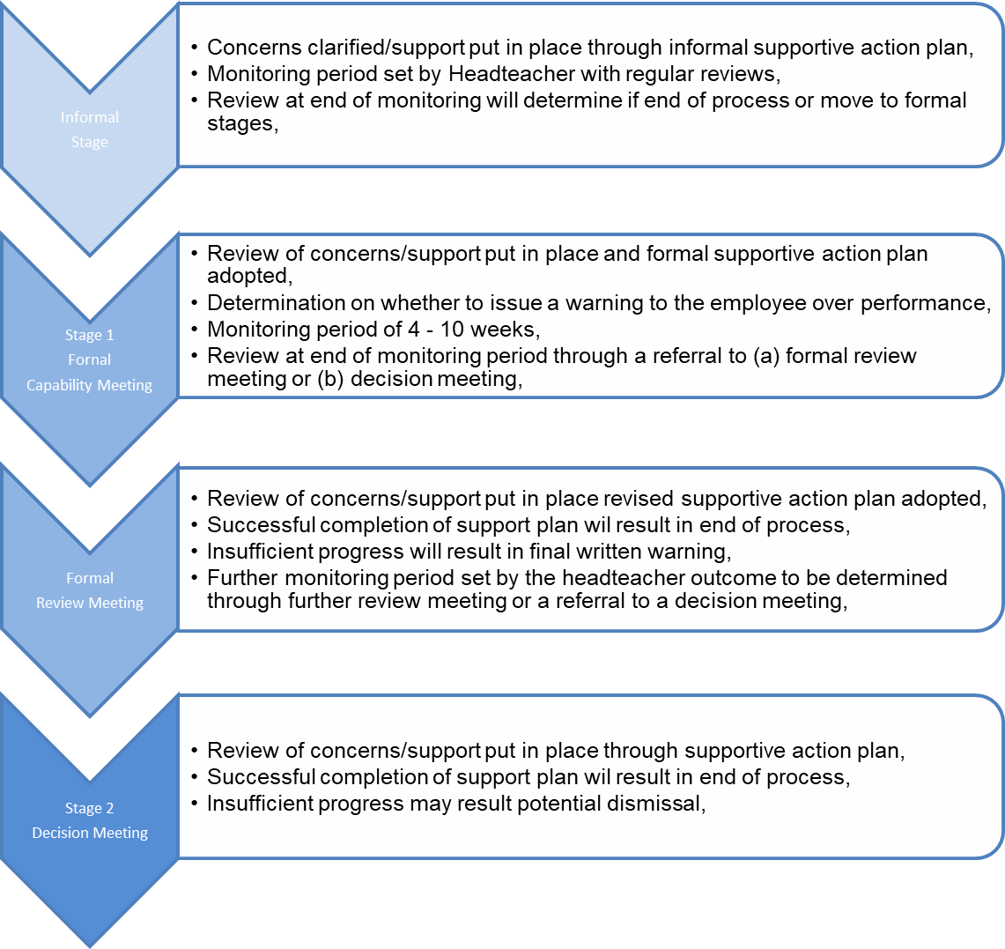

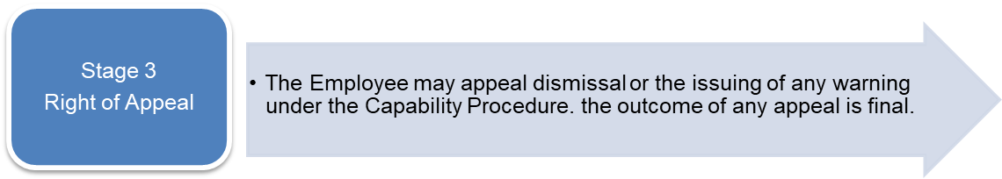

Appendix B: Sample supportive action plan showing detail required.
Employee Name: Manager Name:
This supportive action plan will cover the period from (Date) and conclude on (Date)

Areas requiring improvement | Improvements required and target dates for improvement | How will this be measured? | Planned review dates (during monitoring period) | Support/ training/ development to be provided? |  | Have improvements been met? | Y/N/Partial  Details of Measurements/ Evidence used in making decision | Timescale for ongoing review of progress
Inconsistency in planning | Planning to detail learning outcomes showing progression throughout the week  Planning to show what teacher is doing (e.g., Modelling) and how learning outcomes will be achieved. | Monitoring of planning | Friday [date] and every Friday thereafter until end of review period on Friday [date] | Support from KS1 manager and/or DHT
Inconsistent in adhering to planning. | Planning to be followed to ensure children are taught the skills to make progress. | LLesson observations | Every 2 weeks w/b  [date]  [date]  [date]
Limited differentiation in teaching and children’s books  Limited appropriate Assessment for Learning strategies in place | Learning needs of all abilities catered for especially providing suitable challenge for ‘more able’.  Differentiation observed in lessons and pupil  Lessons graded as satisfactory or better.  Learning outcomes are specific, child friendly and appropriate to task.  Success criteria linked to learning outcomes.  Marking and feedback includes AFL strategies.  Pupils know what they are learning, what they need to do to achieve it and how they can improve.  Teacher feedback is written in school script.  Lessons graded as satisfactory or better | Monitoring of planning  Book scrutiny  Lesson observations  Lesson observations  Book scrutiny  Discussions with children | As above  Every 2 weeks w/b  [date]  [date]  [date]  Every 2 weeks w/b [date]  [date]  [date] | Observe good and outstanding teachers both within school and in other schools in the Local Authority
Poor time management and lack of pace in lessons | · Lesson has appropriate pace.  · Enough time allocated to completion of independent tasks.  · Optimal balance between teaching time and independent work  · Lessons graded as satisfactory or better | Lesson observations | Every 2 weeks w/b [date]  [date]  [date] | Observe good and outstanding teachers both within school and in other schools in the Local Authority
Some pupils are making no progress, and some are making limited progress in lesson time | · Majority of pupils to make progress during each lesson.  · Develop opportunities for collaborative learning through paired discussion and writing.  · All pupils know what they are learning and how well they have achieved against success criteria.  · Lessons graded as satisfactory or better. | Lesson observations  Discussions with children | Every 2 weeks w/b [date]  [date]  [date] | Observe good and outstanding teachers both within school and in other schools in the Local Authority

Employee Comments:

SUPPORTIVE ARRANGEMENTS
Lesson observations to observe strategies for differentiation, assessment for learning, pupil engagement, and pupil progress.
1 hour per week peer coaching with SMT to plan and team teach a session in Y[insert year group] every week.
Feedback given from lesson observations.
1 hour mentoring support (include times) with member of SMT, with an outline of support received.
1 half day visit with APP leading teacher within LA
Additional LA consultancy support 1 session every half term

MONITORING ARRANGEMENTS to begin [date]
Weekly monitoring of planning
Fortnightly pupil book scrutiny.
1 lesson observation every 2 weeks in Year [insert year group].

REVIEW DATES
[DATE]
[DATE]
[DATE]

TARGET DATE FOR COMPLETION: [DAY] [DD/MM/YYYY]

Signature (Manager) ____________________________

Signature (Employee) ______________________________

Appendix C: Decision meeting/appeal meeting – suggested format

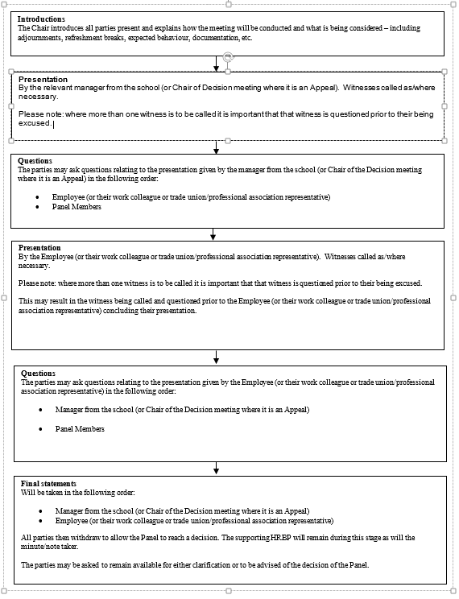

Subject area: | Capability Policy and Procedure
Overview: | As employers’ schools need to be able to provide a framework explaining their values and expectations in relation to their internal staff procedures.  This basic document provides a framework and an explanation for the reader/ user to understand more around the subject matter and to better understand how to appropriately manage attendance in school.  The document has been pre-consulted upon with recognised trade unions to ensure that this document has received the endorsement of those colleagues prior to it being issued to schools. It will provide the minimum expectations required.  This will allow school to develop a capability policy for both teachers and support staff for subsequent adoption, by the governing board.
Issued to schools: | January 2023
Documents Classification: | The document provided is a Category B [GT(1] (please see comments). This document is not intended to be the final document that a school would implement or adopt.
What schools need to do with this document: | Consider the document and compare it to what school has in place currently and whether school feel there is a need to review its existing policy and practice. Insert your own school information in the relevant places. Follow your school consultation and adoption process.
Next review date: | January 2026

Note: Separate procedures are in place relating to probationary periods for support staff and early career teachers (ECT’s).
Mentor could be useful to enable the employee to access a more experienced individual to discuss ideas/methods relating to work/environment in a supportive non-judgemental manner.
If procedure was previously halted at a formal stage, then any subsequent re-entry in a 12 month period would begin at the formal stage, similarly if halted at the informal stage any re-entry would be at this informal stage except in exceptional circumstances outlined elsewhere in the policy.
Any written correspondence should ensure this point is noted.
The principle of no surprises regarding performance issues should be followed throughout this policy.
It is important that any support plan ensures clear and concise record of expectations, actions to be taken and subsequent outcomes. The process should be constructive.
Any consultation will be within the constraints of the school’s data protection policy.
Ongoing communication/information sharing will be encouraged throughout this procedure.
Where employee requests, a copy of the correspondence will also be issued to their trade unions representative / work colleague.
In accordance with the principles of this policy the Appeal Panel do not have the authority to increase the sanction set at the original hearing.

