In Maths we will…  Consolidate our numbers to 10, we will order numbers to 10 and compare numbers to 10. We use practical resources such as Numicon, tens frames and number lines. We then move on to addition and subtraction within 10. We practise number formation and recognising digits and reading numbers in words. |  | Year 1  Autumn Term 2022 |  | In English we will…  Read the Oliver Jeffers story The Way Back Home and talk about the order of the story focussing on retelling the story orally. We will look at the setting of the story. We will read Whatever Next and have super adventures with baby bear in space. We will describe characters using adjectives. We will be focussing on writing simple sentences using capital letters and full stops.
My Home
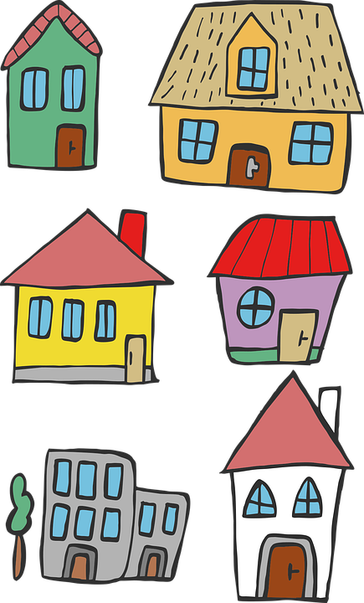
As thinkers in PSHE we will…  Learn about the roles of different people in our lives such as family and friends. We will talk about how to stay safe in relationships and we will learn how to respect ourselves and others. |  |  |  | As thinkers in RE we will…  Be thinking about what do Christians believe about God? We will read Bible stories such as the story of Noah. We will discuss why gifts are given at Christmas and look at the Christmas story.
As Scientists we will…  Be investigating everyday materials and looking at the properties of materials using vocabulary to describe, for example rough, smooth. We will look at the season, Autumn by talking about the features that we see around us. |  | As geographers/historians we will…  Talk about our own homes and learn about homes from the past and how they have changed. We will learn new historical vocabulary such as chronological and use a timeline. |  | As computer scientists we will…  Be learning about Action Algorithms giving instructions and directions to navigate around mazes. We will look at an Introduction to Digital art making pictures using software such as 2Simple.
As sportspeople we will…  Be practising our Dance skills in Indoor P.E, we will use our bodies to make different shapes and to express ourselves through music.  In Outdoor P.E we will be practising our ball skills and throwing and catching aiming games. |  | As artists and technologists we will…  Explore colour and colour mixing using different sizes of brushes. We will make collages using a range of materials. We will draw and paint self portraits.  We will design and make houses using different materials and evaluate our designs. |  | As musicians we will…  Listening and appraising pieces of music saying what we like and dislike. We will be learning to keep a steady beat using body percussion and instruments. We will learn songs and learn about pulse and rhythm.
As linguists we will…  Be able to talk about our experiences in other countries, for example going on holiday. To know France is a country and the people speak French. To say greetings in French to each other and to recognise, read and say numbers to 5 in French. |  | Career links to our learning this term…  Builder  Architect  Estate Agent |  | Wider curriculum opportunities this term include…  A visitor from North Tyneside Careers  A walk around the local area
Texts you can read to support your understanding…  Stories about travel and stories with different settings e.g. The Way Back Home  Any non fiction texts about homes and houses and materials |  | Websites to support learning at home…  Oxford Owl Oxford Owl for School and Home |  | Suggested places for family visits…  The Discovery Museum  Local Library  Centre for Life  Beamish

