In Maths we will…  Consolidate our numbers to 20. We will order and compare numbers to 20. We use practical resources such as Numicon, ten frames, dienes and number lines to support this. We then move on to addition and subtraction within 20. We will continue to practise number formation and reading/ writing numbers in words.  After half term we focus on place value within 50, followed by length and height and mass and volume. |  | Year 1  Spring Term |  | In English we will…  Read a selection of fairy tales, including Little Red Riding Hood and our main focus will be Cinderella. We will look at story structure and focus on beginning, middle and endings. We will look at fairy tale language and the characters. We will be focussing on writing simple sentences using capital letters and full stops and trying to extend our sentences using and. We will write recounts including a diary entry for a fairy tale character. We will also link to our History topic and write a recount of a visit from That History Bloke. In the second part of the term we will read Lost in the Toy Museum focussing on settings and descriptions.
Toys from the past
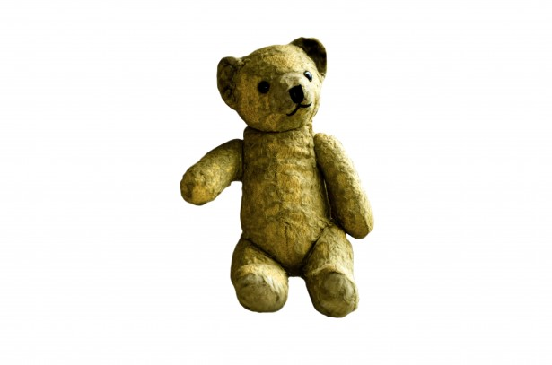
As thinkers in PSHE we will…  Learn what it means to be part of a community. We will talk about the importance of rules and caring for others' needs. We will learn how and why people use the internet and we will learn how to communicate safely with others online. We will have a visit from a PCSO who will talk to use about the role they play in the community. |  |  |  | As thinkers in RE we will…  Ask the question, why is Jesus important to Christians? We will cover a variety of stories from the Bible, including Jesus calming the storm, the parable of the lost sheep and the story of the blind beggar.  After half term, we will focus on the Easter story.
As Scientists we will…  Be learning all about plants. We will design our own gardens and find out about different types of plants including wild flowers. We will have a go at planting beans and keep a diary to chart growth. Our season we will focus on will be Winter by talking about the features that we see around us. |  | As geographers/historians we will…  We will learn about Toys from the past and compare them to toys today. We will talk about differences and similarities. We will learn new historical vocabulary and use a timeline. We will create posters of toys from different decades. We will also have a visit from ‘That History Bloke’. |  | As computer scientists we will…  Be learning about multi media stories using 2Simple software and Purple mash to make our own stories. We will focus on using the keyboard to type and to use tools to draw pictures. We will also look at Action algorithms following instructions and writing our own instructions to move around a maze.
As sportspeople we will…  Be practising our Gymnastics in Indoor P.E, we will use our bodies to practise bouncing, leaping and moving around. We will also use apparatus and focus in traveling and making sequences of movements and routines.  In Outdoor P.E we will be practising our ball skills and throwing and catching aiming games. |  | As artists and technologists we will…  Designing and making a moving story picture book of Humpty Dumpty using sliders. We will read our stories to EYFS children.  In Art we will look at the work of Henri Rousseau and focus on leaf/nature printing. |  | As musicians we will…  Listening and appraising pieces of music saying what we like and dislike. We will be learning about timbre and rhythmic patterns.We will look at how instruments can produce different sound effects.to help tell a story The topic of fairy tales will link to our English.
As linguists we will…  say greetings in French to each other and to recognise, read and say numbers to 5 in French. |  | Career links to our learning this term…  Gardeners  Scientists  Authors  Designers |  | Wider curriculum opportunities this term include…  A visit from ‘That History Bloke’
Texts you can read to support your understanding…  Fairy tales and traditional tales  Any non fiction texts about Toys, materials and plants |  | Websites to support learning at home…  Oxford Owl Oxford Owl for School and Home |  | Suggested places for family visits…  The Discovery Museum  Local Library  Rising Sun park  Beamish

