In math we will…  Start by covering essential elements of place value such as reading and writing, comparing and ordering large numbers. We will also round to different degrees of accuracy and look at the importance of decimals.  We will then move on to the four operations and consolidate methods for addition, subtraction, multiplication and division. | Year 6  Autumn Term | In English we will…  Read Floodland by Marcus Sedgwick and The Rain Player by David Wisniewski. We will complete a range of activities linked to these books including vocabulary work, writing effective story openings and closings, punctuating dialogue and writing journey, quest and adventure narratives. We will also cover non-fiction units such as persuasive letters and explanation texts.
The Mayans and The Americas

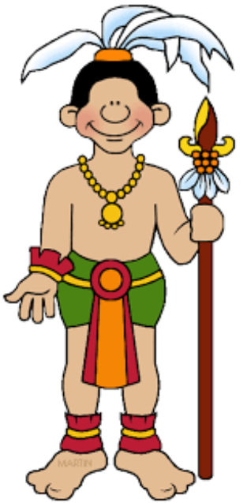
As thinkers in PSHE we will…  Discuss elements of health and well-being and positive relationships. We will learn about how to look after our own mental and physical health as well as those around us. |  | As thinkers in RE we will…  Study what it means to be a Humanist. We will learn about Humanist viewpoints and compare this ideology to more well-known religions.
As scientists we will…  Be studying Electrical Circuits and How We See Things. Both units will involve practical investigations in which children we learn key concepts through hands-on activities. | As geographers/historians we will…  We will begin by locating North American and South American countries, look at the effect of plate tectonics and learn divisions of the Earth. We will then move on to The Mayan Civilisation and study their beliefs and ways of life. | As computer scientists we will…  Study spreadsheets and digital literacy. Children will use a range of computer programs such as Microsoft Excel, Word, Powerpoint and Publisher in order to complete a range of activities designed to facilitate learning.
As sportspeople we will…  Be practising the skills of synchronization and cannon in dance, and playing hockey and football in our invasion games units of outdoor PE. | As artists and technologists we will…  Be designing and refining recipes, creating a healthy balanced meal suitable for a premier league footballer! We will be using the skills of chopping, slicing, grating and mixing to prepare our dishes. | As musicians we will…  Study complex musical rhythms before using our new knowledge to compose a piece of music and write it down using standard notation.
As linguists we will be…  Studying French clothing. | Career links to our learning this term…  - Historian  - Geologist | Wider curriculum opportunities this term include…  - Continents and oceans of the world  - Ancient history
Texts you can read to support your understanding…  The History Detective Investigates: Mayan Civilisation  The Great Kapok Tree by Lynne Cherry  50 Adventures in 50 States by Kate Siber and Lydia Hill | Websites to support learning at home…  https://www.dkfindout.com/uk/history/mayans/#!  https://historyforkids.org/ancient-mayans-facts-for-kids/ | Suggested places for family visits…  - Great North Museum (Hancock)  - Life Science Centre  - Discovery Museum

